CURRICULUM
Following the CBSE curriculum, we have divided it in various slots to treat them accordingly.
Pre-Primary- This segment is purely based on activities which helps the students to learn basic and elementary concepts of school education.

Primary Section(Grade- 1st-5th)
The secret of getting ahead is getting started. So we are keener for the start-up classes. These tiny and tender tulips are nurtured here very lovingly and carefully with strong and clear conceptual knowledge and learning basics of all subjects at this grass root level.
The whole teaching methodology is rotating around the overall development of a child.
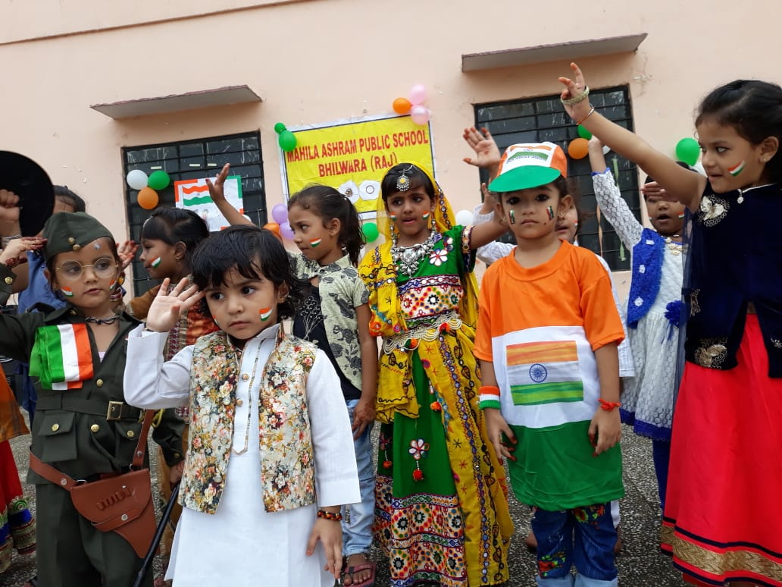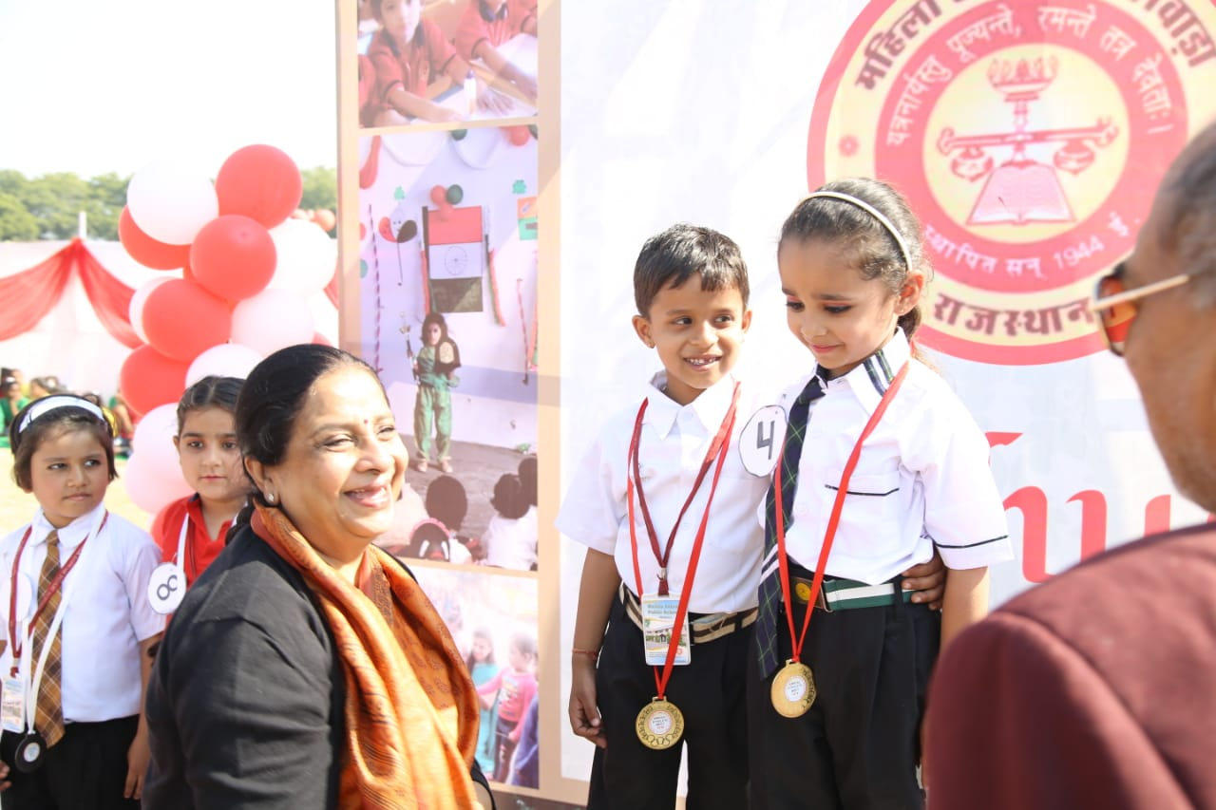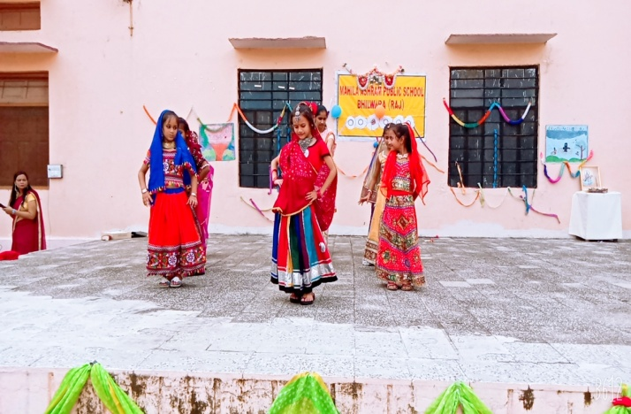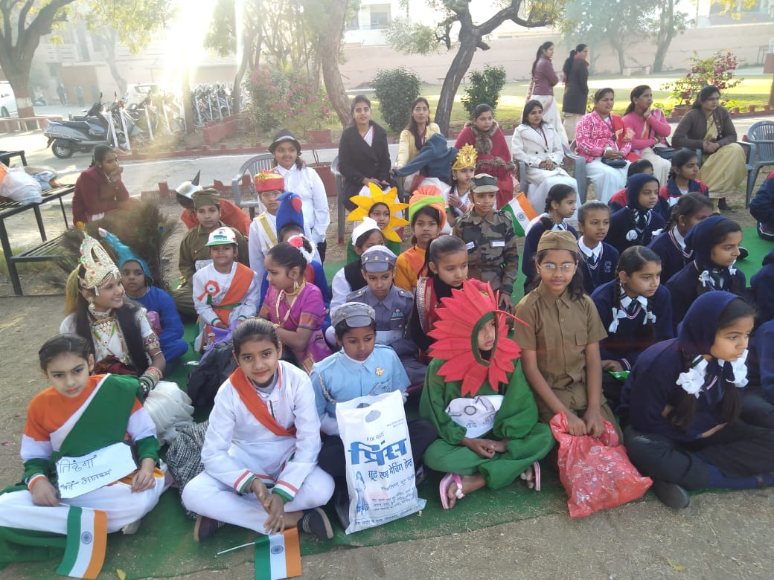

Middle Section(Grade- 6th -8th)
Teaching the middle classes is not a job, it’s actually an adventure to keep this in mind, and we have designed the curriculum of middle classes, so that they can be capable to meet out challenges of coming future.
In English we are more focused on phonics, reading and writing part.
In Hindi and Sanskrit also we are following the same pattern.
In mathematics general concepts and basics of the subject is to be stronger.
SSt. is the subject which makes students less confident all the time. Due to variety of subject’s viz. History, Civics, Geography and Economics.
Modern audio – visual method is also used to teach these subjects.
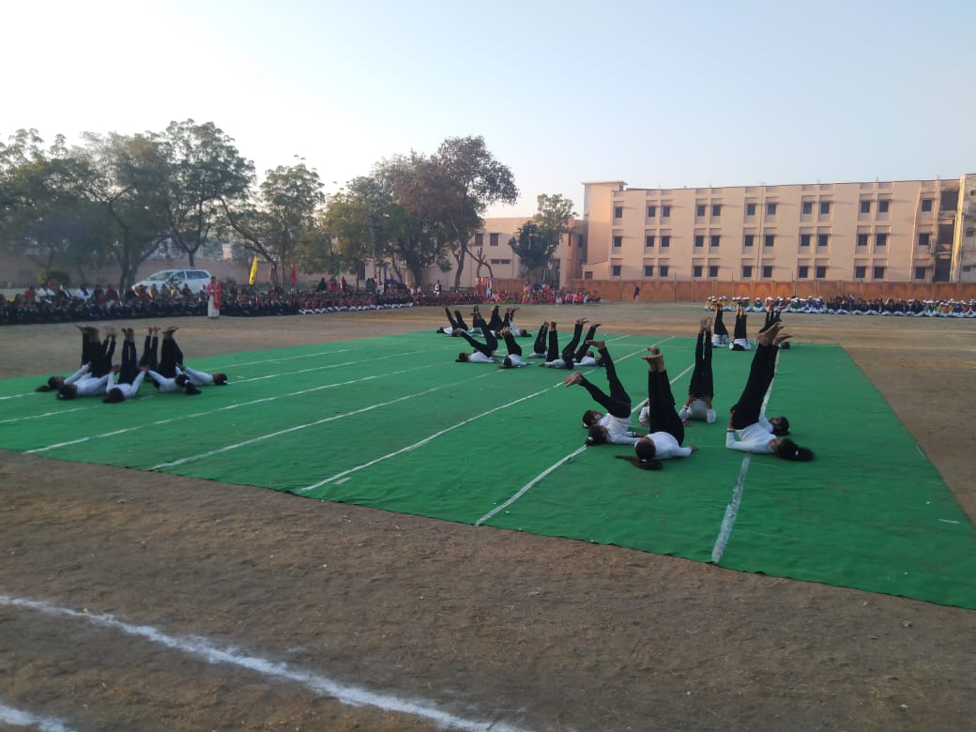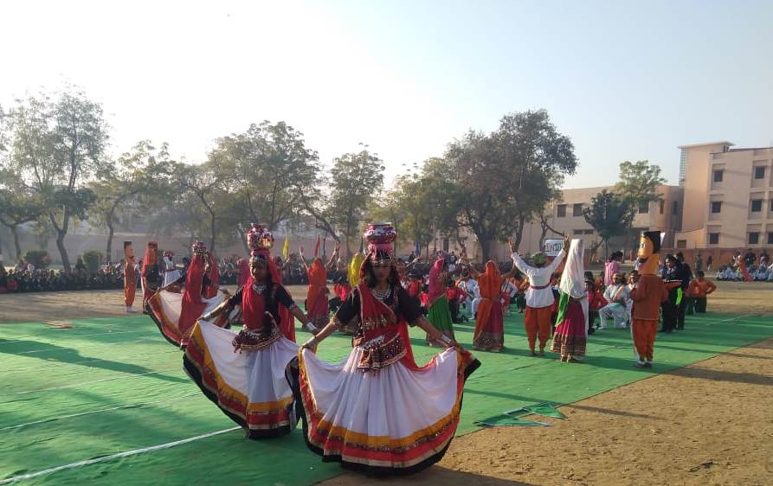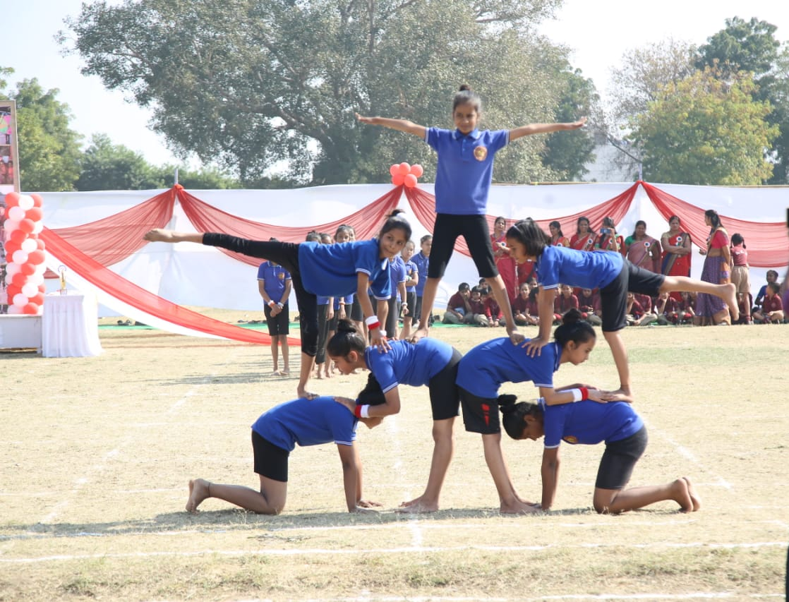
Senior Section(Grade- 9th -10th)
This segment is very crucial as they are stepping into the world of more competition more tough situations. So we are strict to make them more focused on their futuristic approach.
At this stage education is the key to unlock the world or a passport to fly high in the sky.
We are glad to inform that we are starting two skill development subjects from this new session(2020-21) name of the subjects are- Information Technology(402) and Agriculture (408). The students have to choose any one of them as their 6th subject.
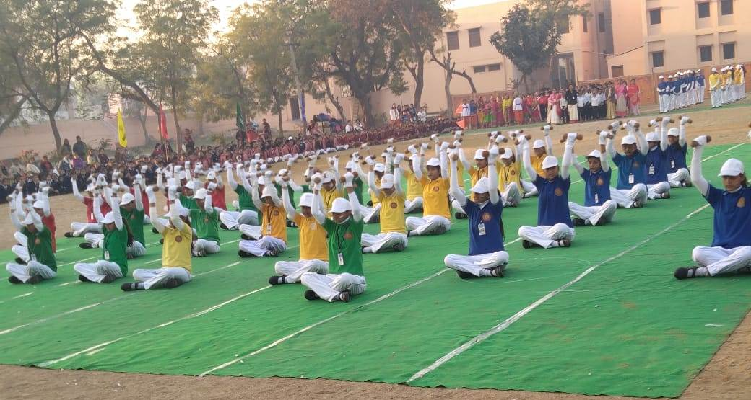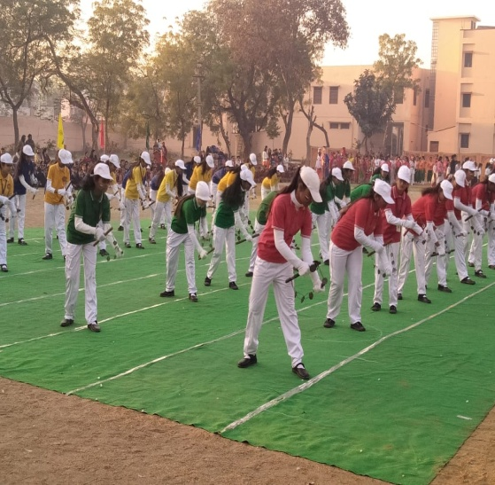
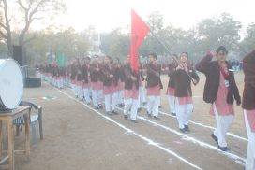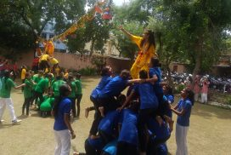
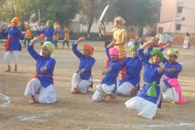

Senior Section(Grade-11th -12th)
Here in MAPS Campus, we are trying to give wings to the thoughts, a ground to the dreams and the support to get success.
All the three streams are running successfully. We are also providing special GK. Classes to concrete the base of these senior girls so that they can complete in a firm and confident way.
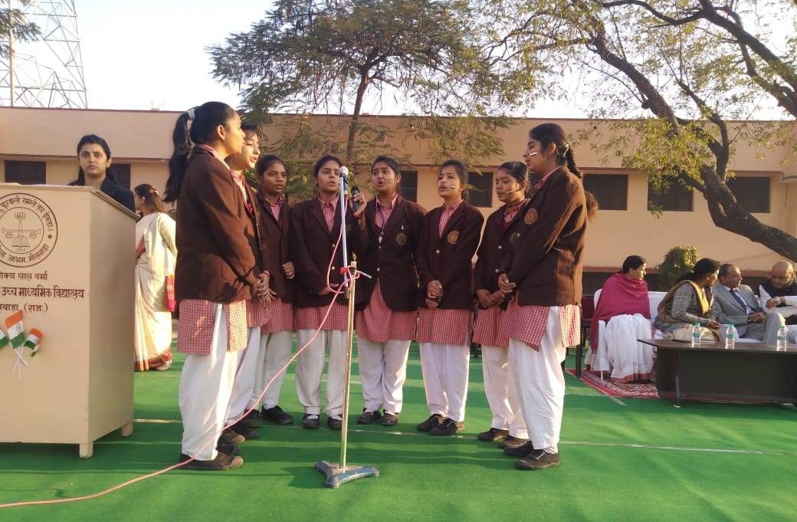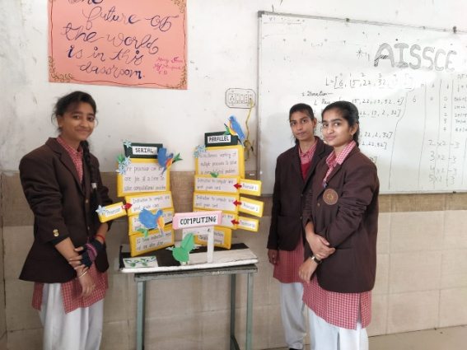
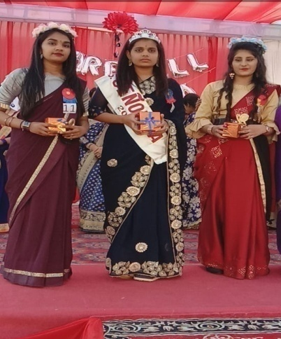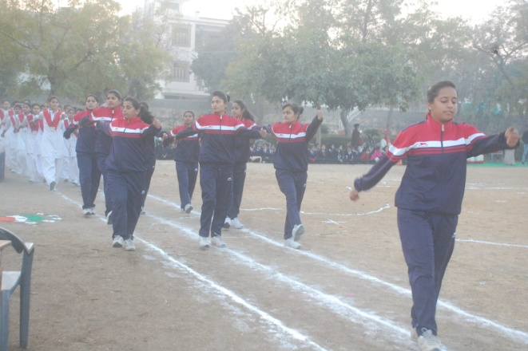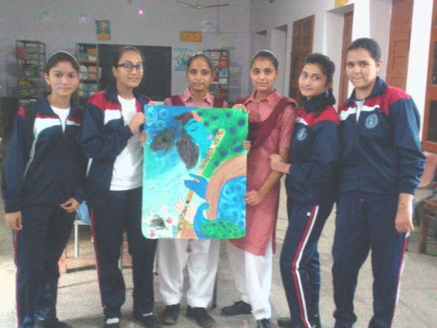
SUBJECT OFFERED:
SCIENCE-PCM/PCB + PHE/CS
COMMERCE- ACCOUNTS/BST/ECO. +PHE /IP/MATH
ARTS – HISTORY/ECO. , ENGLISH LITE./ POLITICAL SCI., GEOGRAPHY + PHE/CS
Some more new subjects in future pipeline…

